Technical Documentation

GameSnipe Online Store

This documentation is designed for Employees and company members who are able to edit the GameSnipe Website. First is to Sign In to an Employee account.

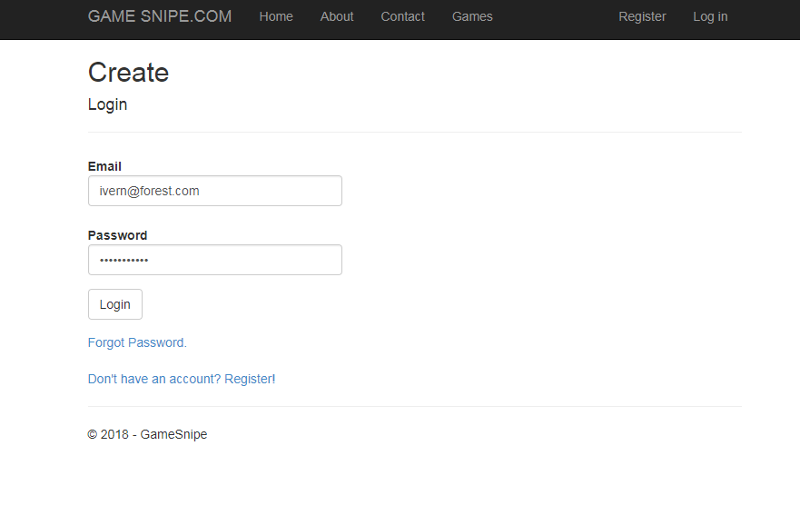

Employee accounts have access to a special page Known as “Employee Features”

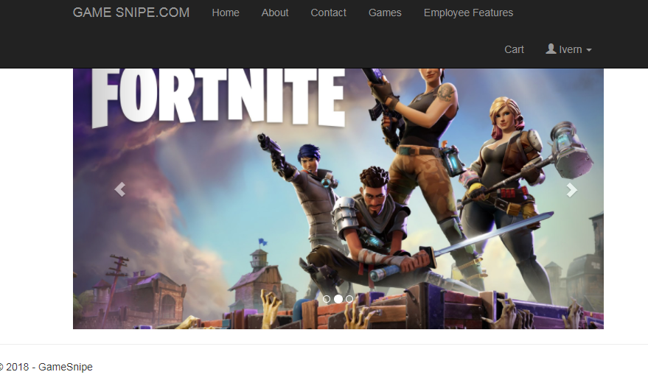

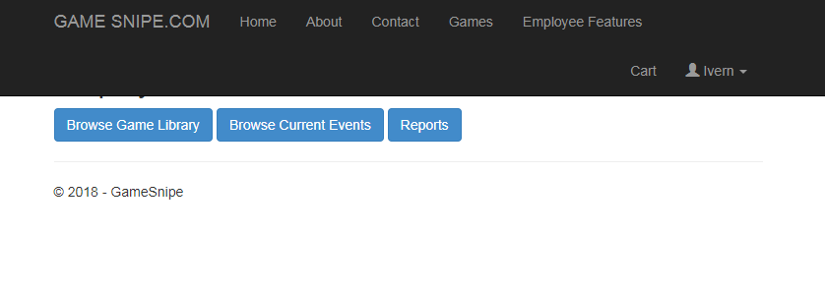In the Employee Features Page Employee Accounts have access to Browse Games, Browse Current Events and Reports pages first we will look at Browse Games.

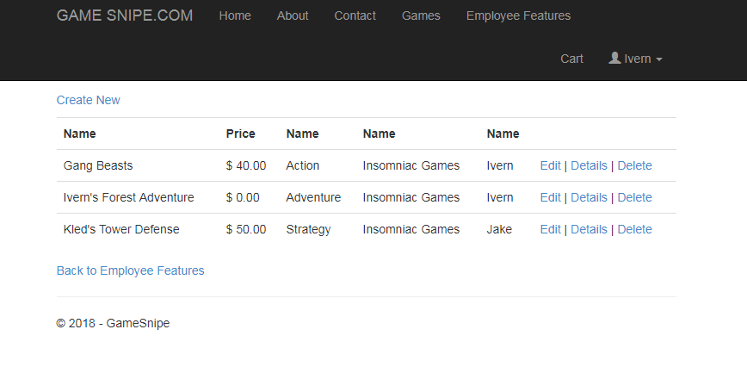In the Browse Games Page you are able to view all available games you are also able to…

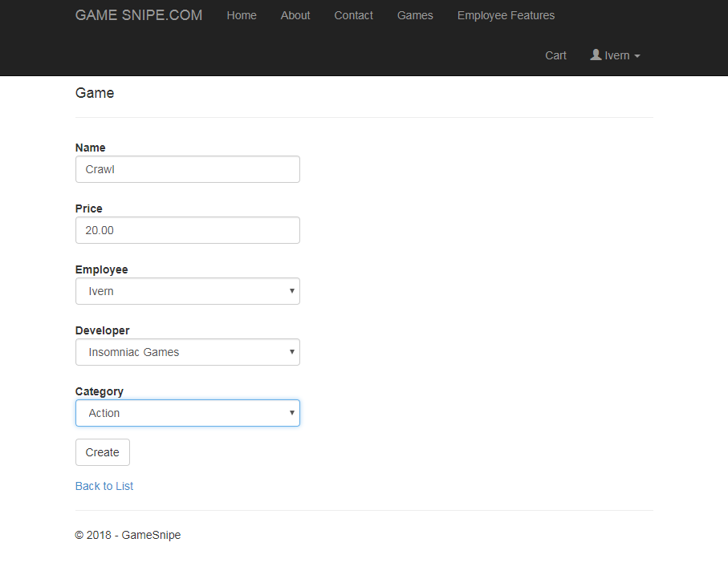Add games through a form

Edit Existing games through a f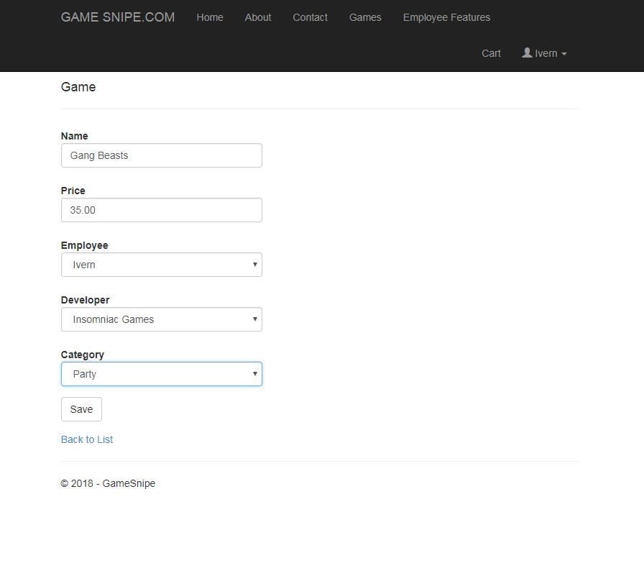orm

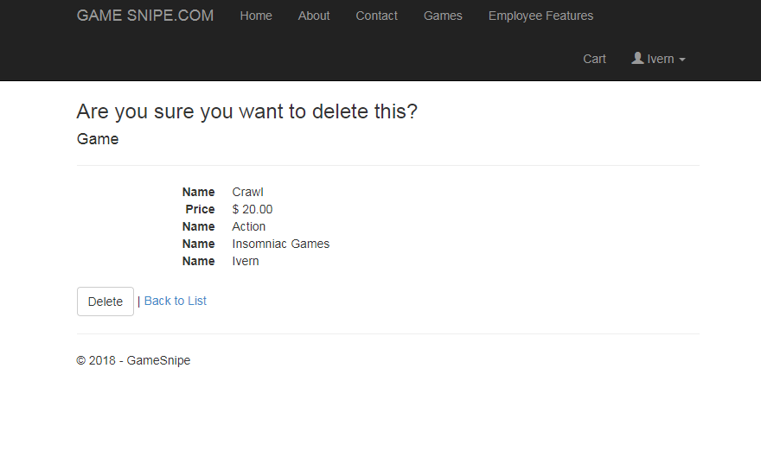And Delete games from the store

You can also Add Edit and Delete Current Events on the website

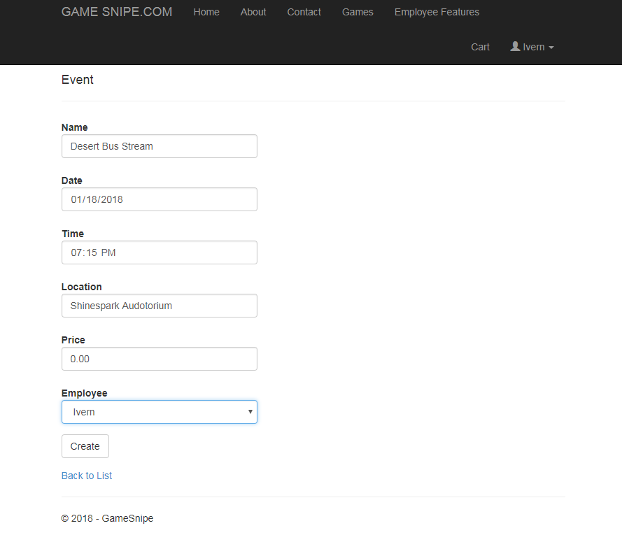Add

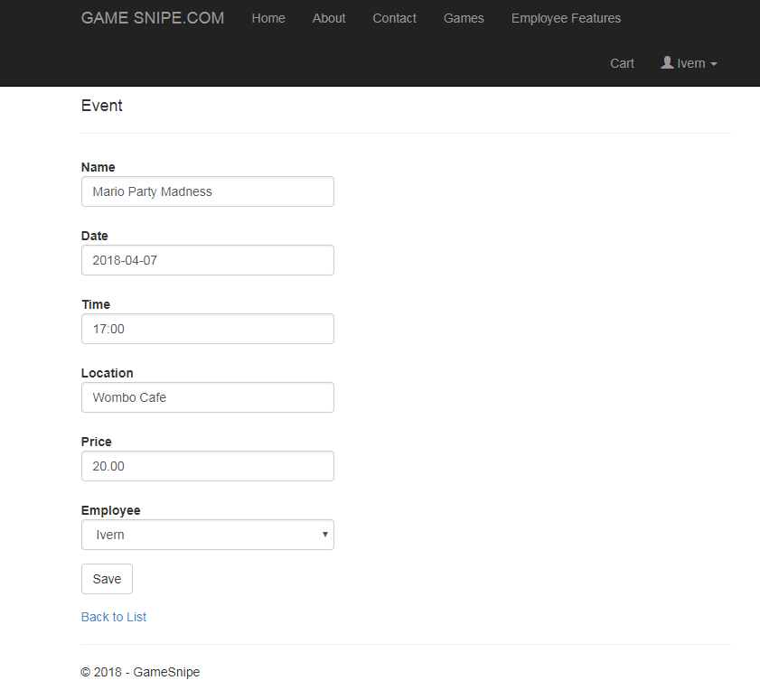Edit

Delete Event

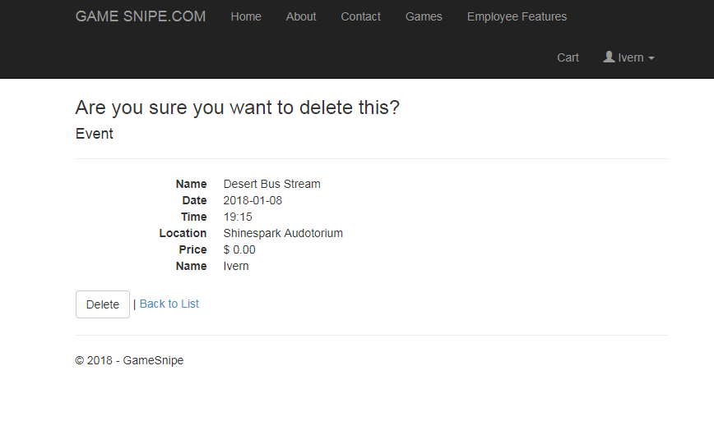

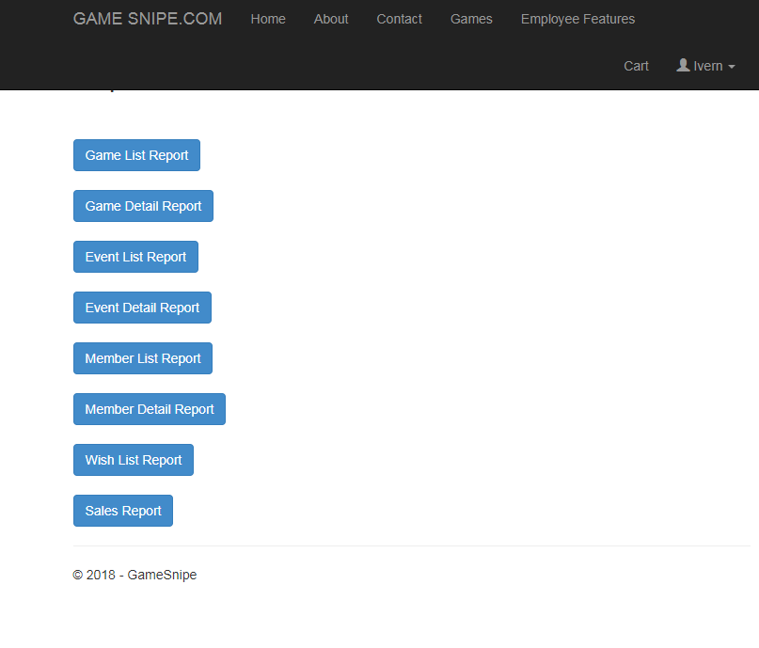On the Reports Page you can click different buttons to produce reports on the website.

For example clicking the Game List Report button makes a report list of all game titles on the website.

